- 基础计数器（理解基本概念与内存分配）
Counter.java:

package demo;
public class Counter {
private int instanceCount ;

private static int classCount = 0 ;
public Counter() {
this.instanceCount = 1;
classCount++;
}

public int getInstanceCount(){
return this.instanceCount;

}

public static int getClassCount(){
return classCount;

}
}

Test.java:

package demo;
public class Test {
public static void main(String[] args){
System.out.println("初始总数" + Counter.getClassCount());
Counter c1 = new Counter();
System.out.println("创建第一个对象后的实例计数" + c1.getClassCount()+ ",总计数：" + Counter.getClassCount());
Counter c2 = new Counter();
System.out.println("创建第二个对象后的实例计数" +c2.getClassCount()+ ",总计数："+ Counter.getClassCount());
Counter c3 = new Counter();
System.out.println("创建第三个对象后的实例计数" + c3.getInstanceCount() + ",总计数：" + Counter.getClassCount());
}
}

测试样例和结果：
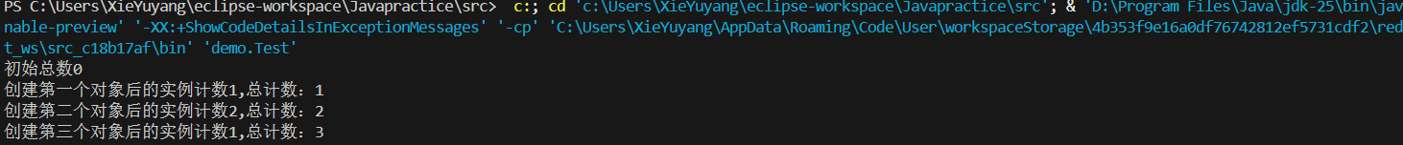

- 银行账户与利率（理解应用场景与设计）

BankAccount.java:

public class BankAccount {
private String accountId;
private double balance;

private static double annualInterestRate;
public BankAccount(String accountId, double balance) {
this.accountId = accountId;
this.balance = balance;
}

public double calculateMonthlyInterest() {
return balance * (annualInterestRate / 12);
}

public static void setAnnualInterestRate(double rate) {
annualInterestRate = rate;
}

public String getAccountId() { return accountId; }
public double getBalance() { return balance; }
}

TestBank.java:

class TestBank {
public static void main(String[] args) {

BankAccount acc1 = new BankAccount("A001", 10000);
BankAccount acc2 = new BankAccount("B002", 20000);
BankAccount.setAnnualInterestRate(0.03);

System.out.println("利率 3% ");
System.out.println("账户1 月利息: " + acc1.calculateMonthlyInterest());
System.out.println("账户2 月利息: " + acc2.calculateMonthlyInterest());

BankAccount.setAnnualInterestRate(0.05);

System.out.println("利率修改为 5% 后 ");
// 观察变化：不需要修改acc1和acc2对象，它们的计算结果会自动变化
System.out.println("账户1 月利息: " + acc1.calculateMonthlyInterest());
System.out.println("账户2 月利息: " + acc2.calculateMonthlyInterest());
}
}

测试样例和结果：
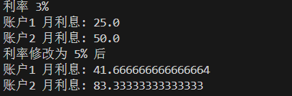

3．单例模式与工具类
Part A: 单例模式 (Singleton Pattern)

import java.util.HashMap;
import java.util.Map;

public class ConfigurationManager {
private static ConfigurationManager instance;

private Map<String, String> configData;

private ConfigurationManager() {
configData = new HashMap<>();
configData.put("AppName", "MyJavaApp");
}

public static ConfigurationManager getInstance() {
if (instance == null) {
instance = new ConfigurationManager();
}
return instance;
}

public String getConfig(String key) {
return configData.get(key);
}

public void setConfig(String key, String value) {
configData.put(key, value);
}
}
Part B: 工具类 (Utility Class)
public class MathUtils {

private MathUtils() {

throw new UnsupportedOperationException("工具类不能实例化");
}
public static int max(int a, int b) {
return (a > b) ? a : b;
}
public static double circleArea(double radius) {
return Math.PI * radius * radius;
}
}

class TestPatterns {
public static void main(String[] args) {

ConfigurationManager cm1 = ConfigurationManager.getInstance();
System.out.println("初始配置 AppName: " + cm1.getConfig("AppName"));
cm1.setConfig("Version", "1.0.0");
ConfigurationManager cm2 = ConfigurationManager.getInstance();
System.out.println("通过cm2获取Version: " + cm2.getConfig("Version"));
System.out.println("cm1 和 cm2 是否相同: " + (cm1 == cm2));
System.out.println("\n--- 测试工具类 ---");
System.out.println("最大值 (10, 20): " + MathUtils.max(10, 20));
System.out.println("半径为3的圆面积: " + MathUtils.circleArea(3.0));
}
}

测试样例和结果：
